**ASSIGNMENTS ON DIGITAL MARKETING**

**NAME: STEPHEN PRAVEEN A**

**DEPARTMENT:** BE ELECTRONICS AND COMMUNICATION ENGINEERING

**COLLEGE:** 8151 DHANALAKSHMI SRINIVASAN INSTITUTE OF

TECHNOLOGY

**NAANMUDHALVAN COURSE**: DIGITAL MARKETING

**NM ID: 56701D9937C29BBABAF43E5455D62A21**

**ASSIGNMENT 1:**

Create a blog or website using Blogspot and WordPress. Customize The theme design and post new article with 500 words.

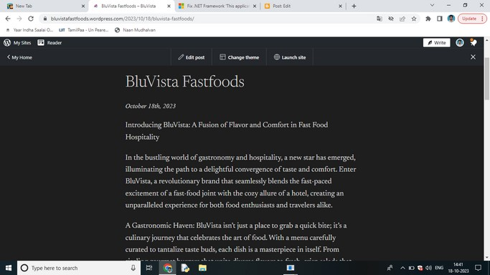

[https://bluvistafastfoods.wordpress.com](https://bluvistafastfoods.wordpress.com/)

**ASSIGNMENT 2:**

Create a new Facebook business Page and Post one social media poster for your brand.

<https://www.facebook.com/profile.php?id=61550516221534&mibextid=ZbWKwL>

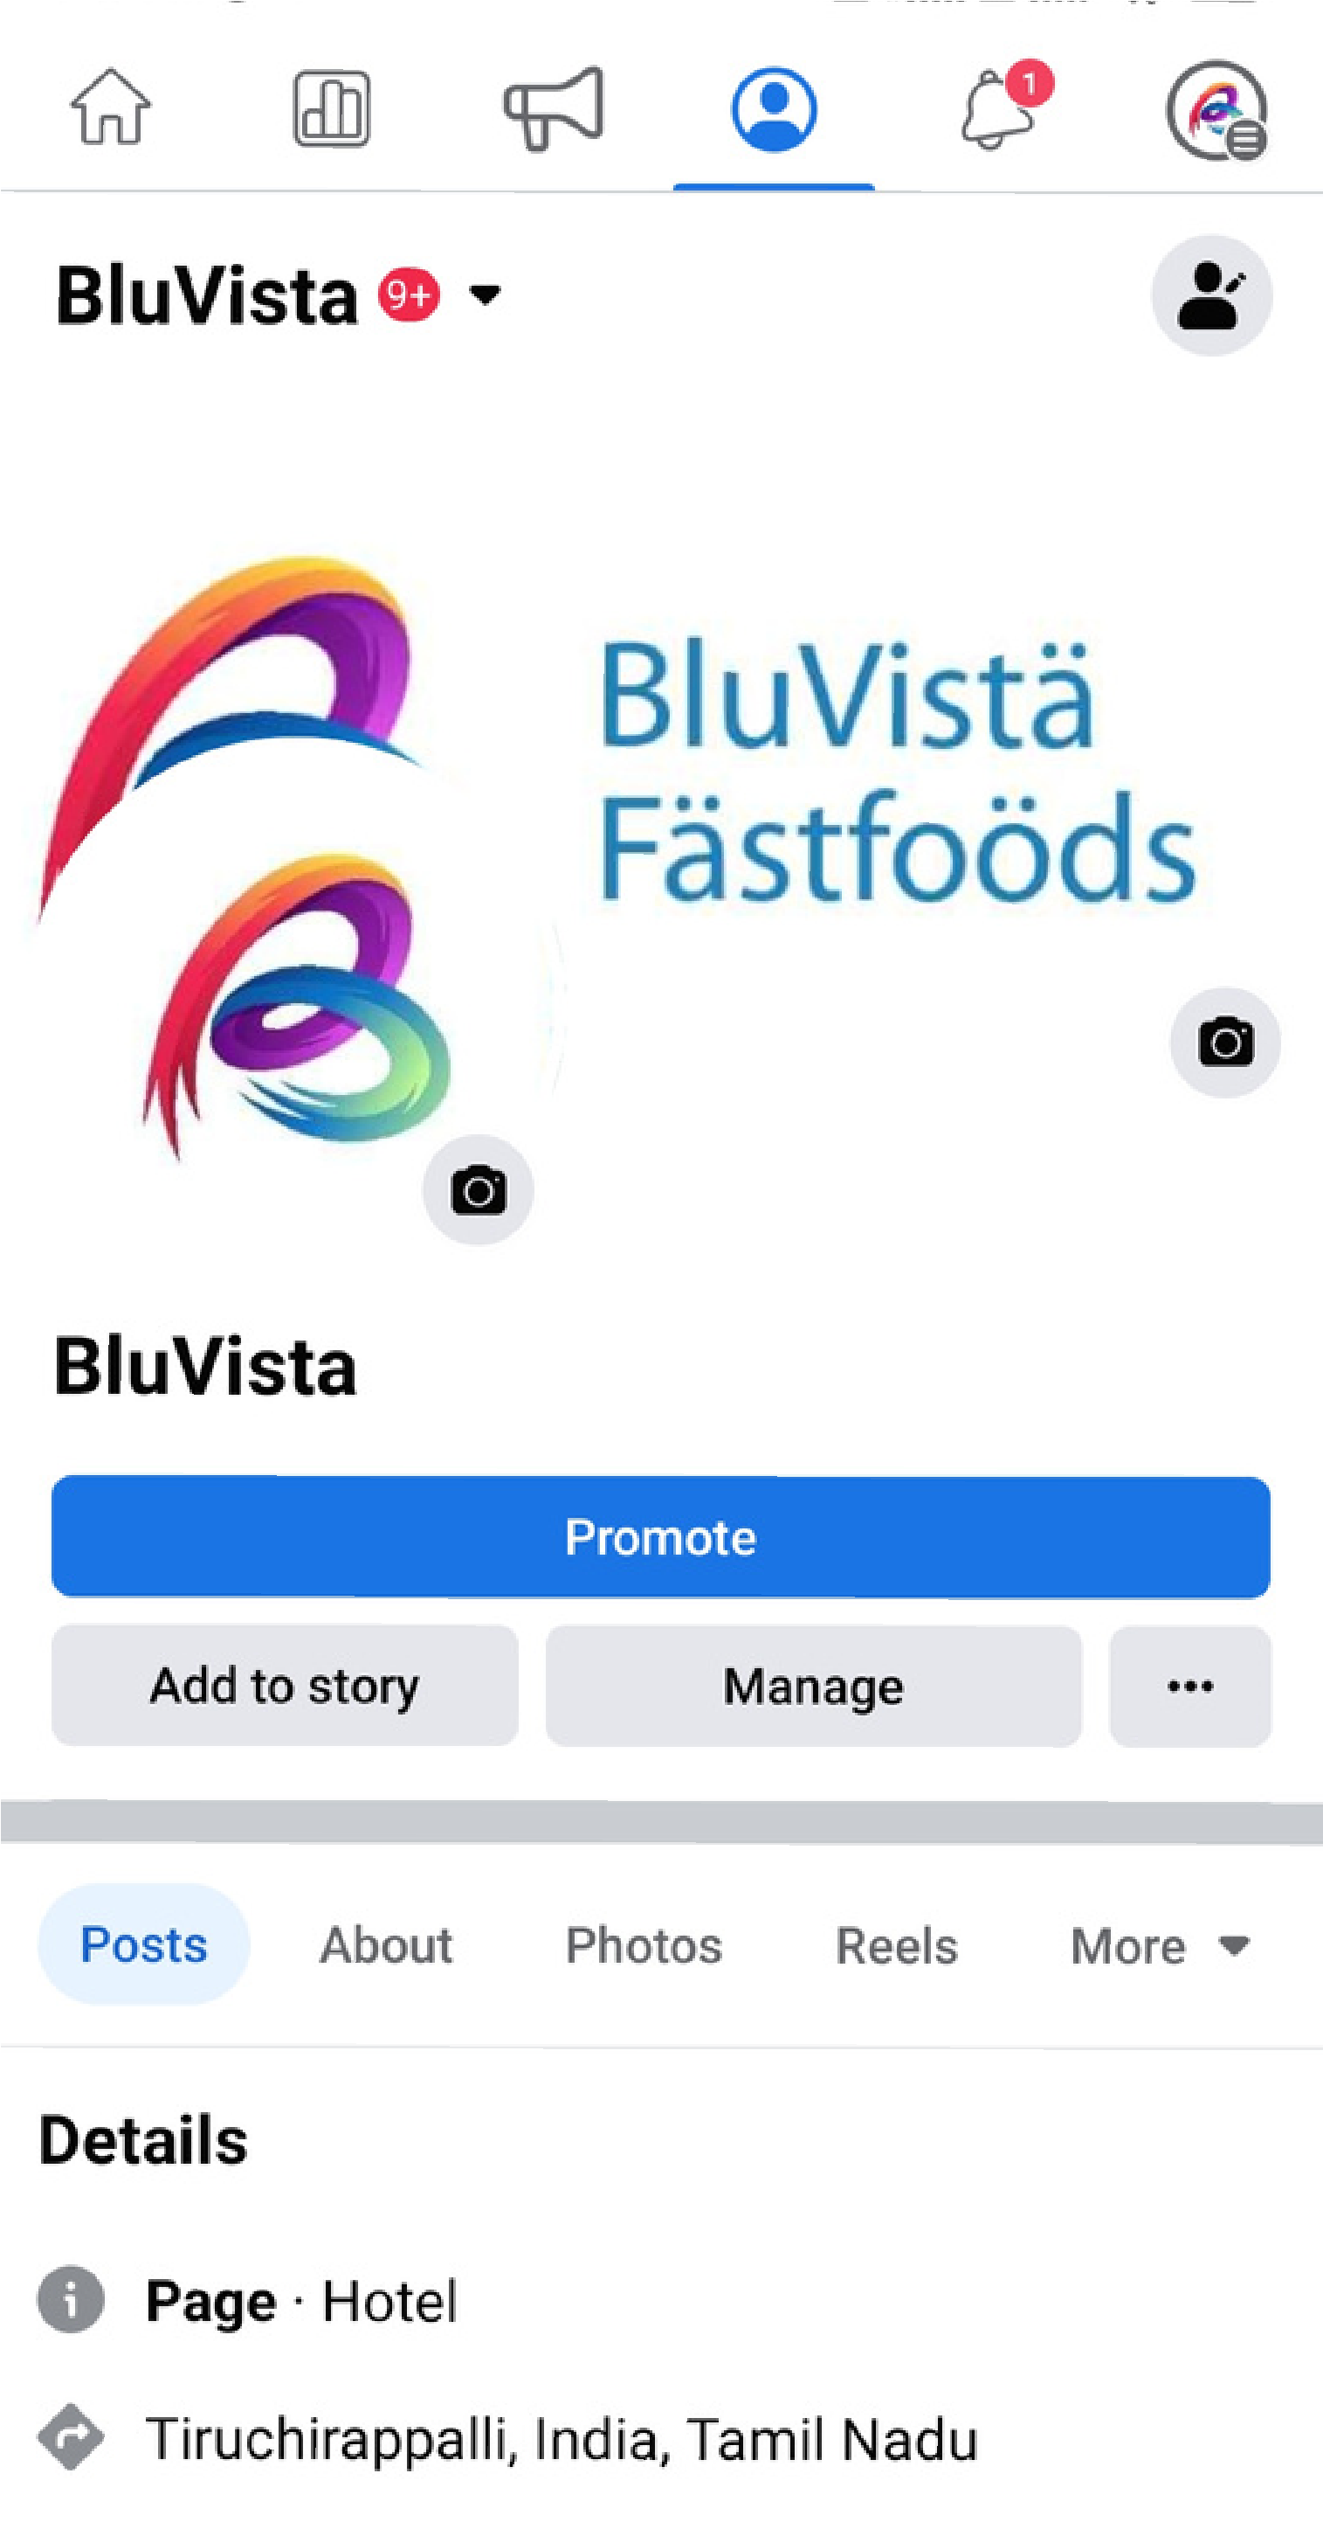

**ASSIGNMENT 3:**

Create and design a social media advertisement poster using Canva.

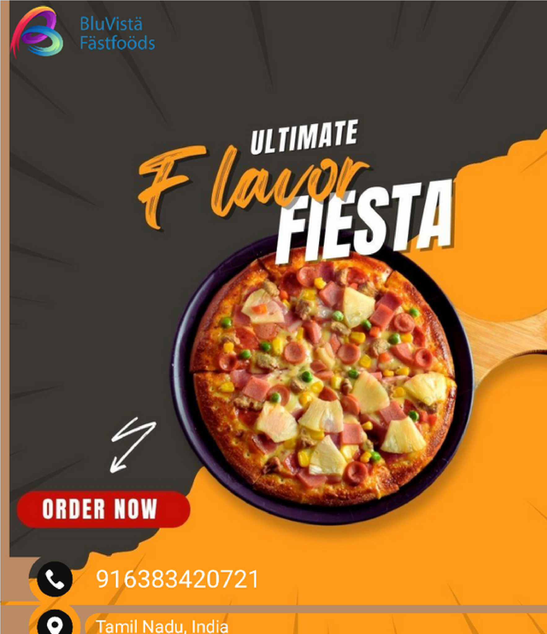

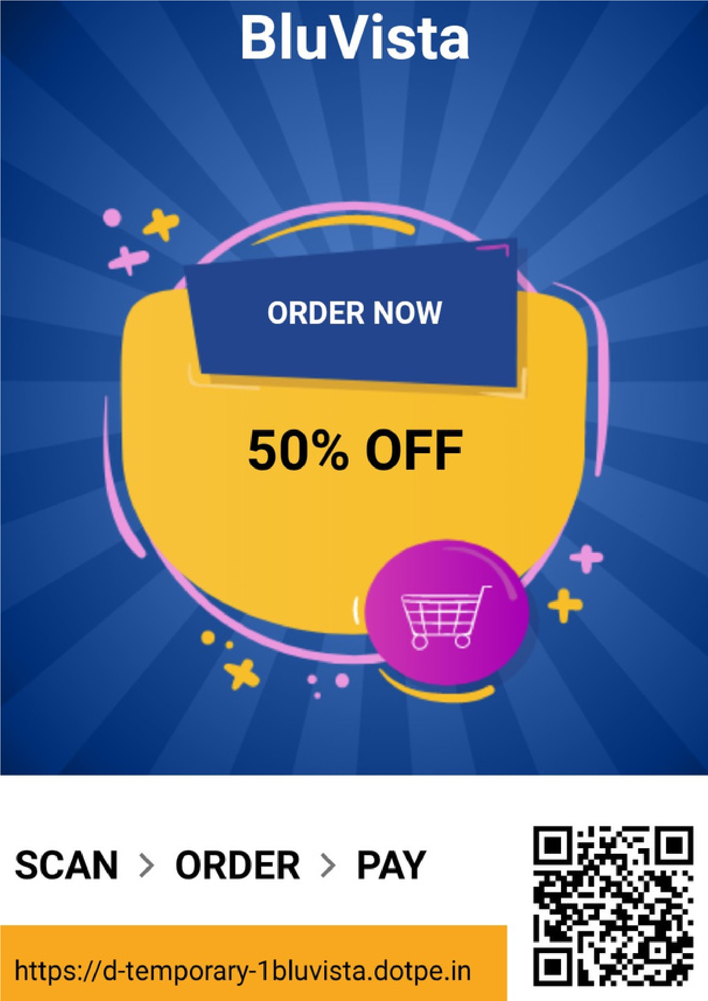

**ASSIGNMENT 4:**

Create email newsletter design using MailChimp or Canva tool.

